**For Task 1: Simple web functionality**

Source Code: task1.js

1. Created below web form with an additional prompt named ‘Contact Number’. Form mapped to *URL “/” and method GET.*

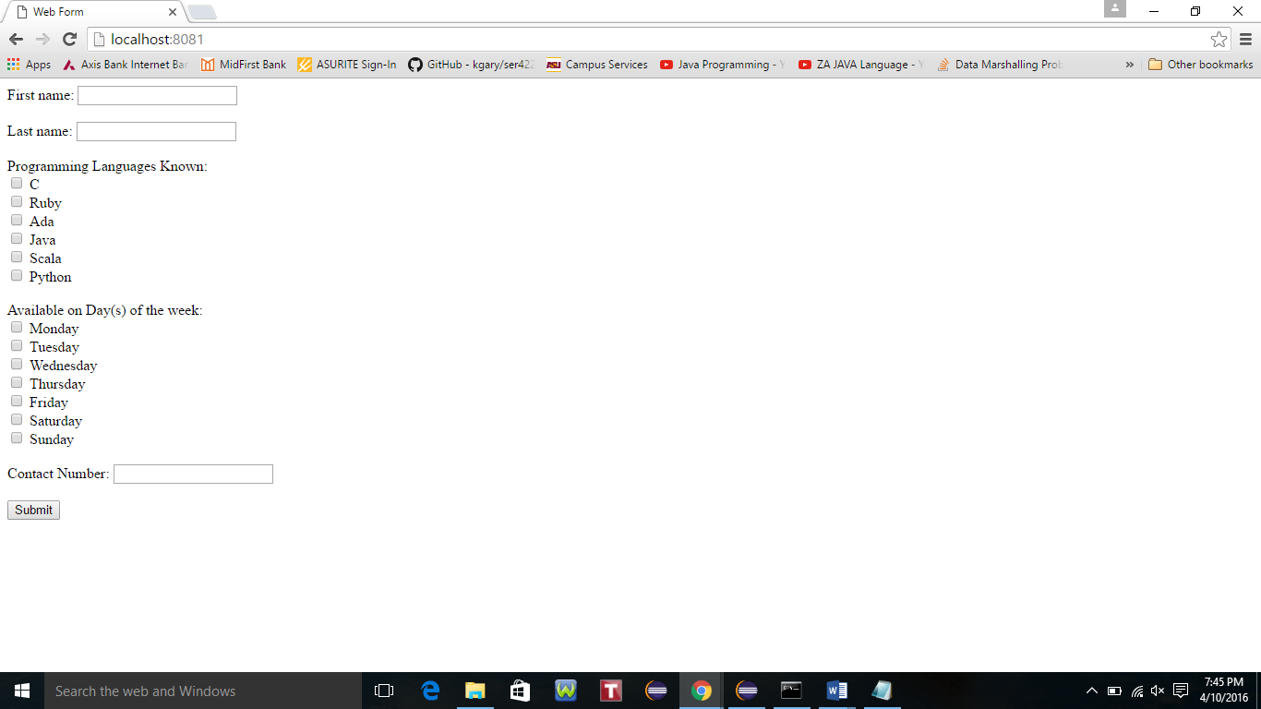

2) Start the server by running task1.js

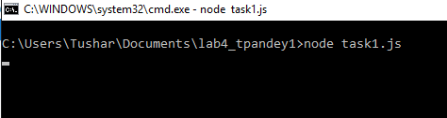

Enter the required details and click submit.

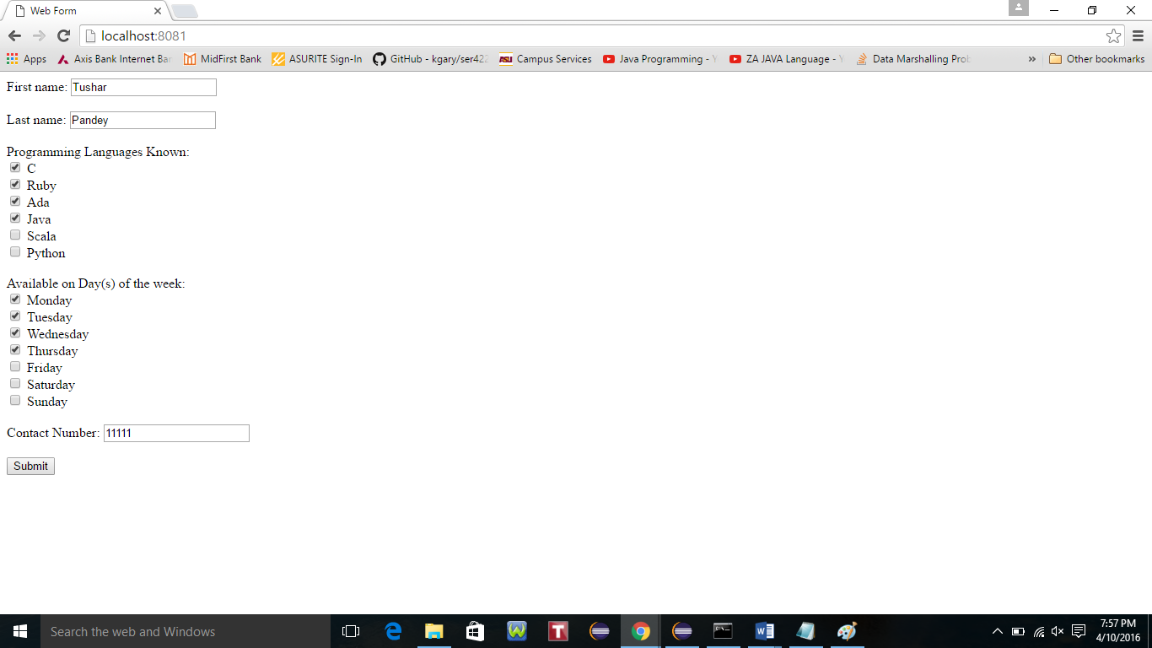

The page displays the message “The action was successful” along with the Total number of entries in the array i.e 1 in this case. The server responds with a message stating the action was successful (or not) followed by a count of the number of entries in the array, and then display the same web form as step #1.

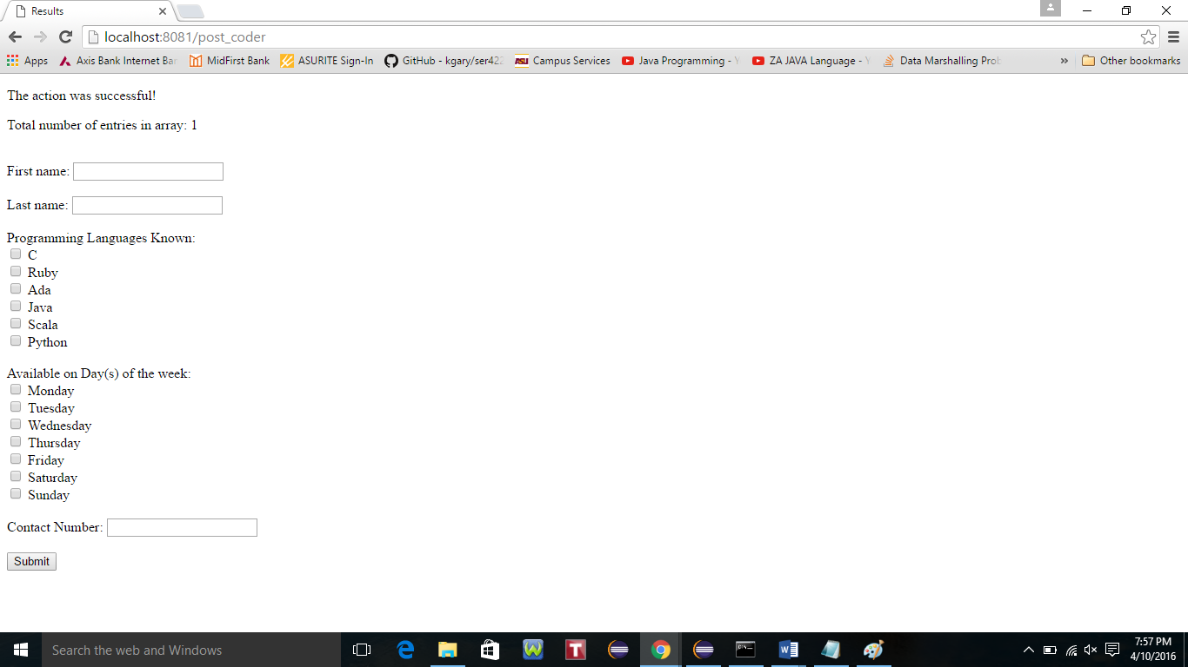

Similarly, enter the other record for testing in further steps. 4 records were added for testing purpose.

If the user provides No value for any of the prompts and clicks Submit to add the empty record, then the program throws an error **“The action was not successful. Please try again.”**

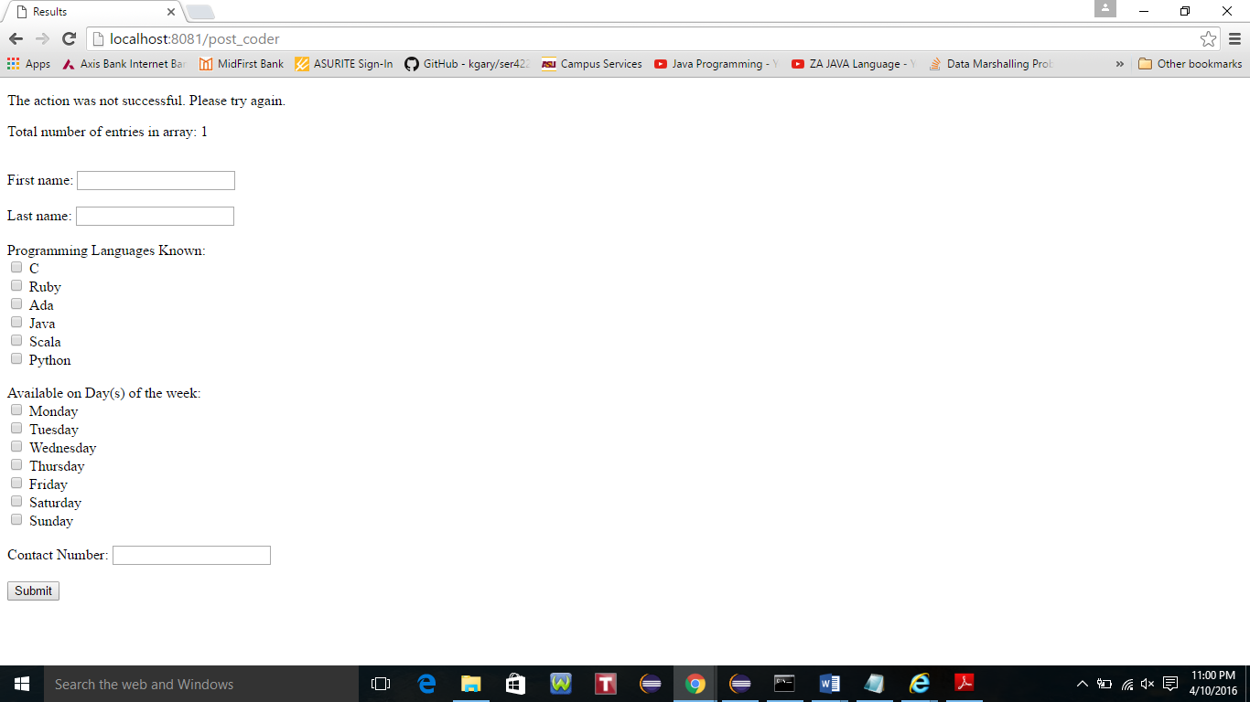

3) On the url enter <http://localhost:8081/coders> to display the entire list of element in array. If the browser is a Chrome browser, then set a pink background color.

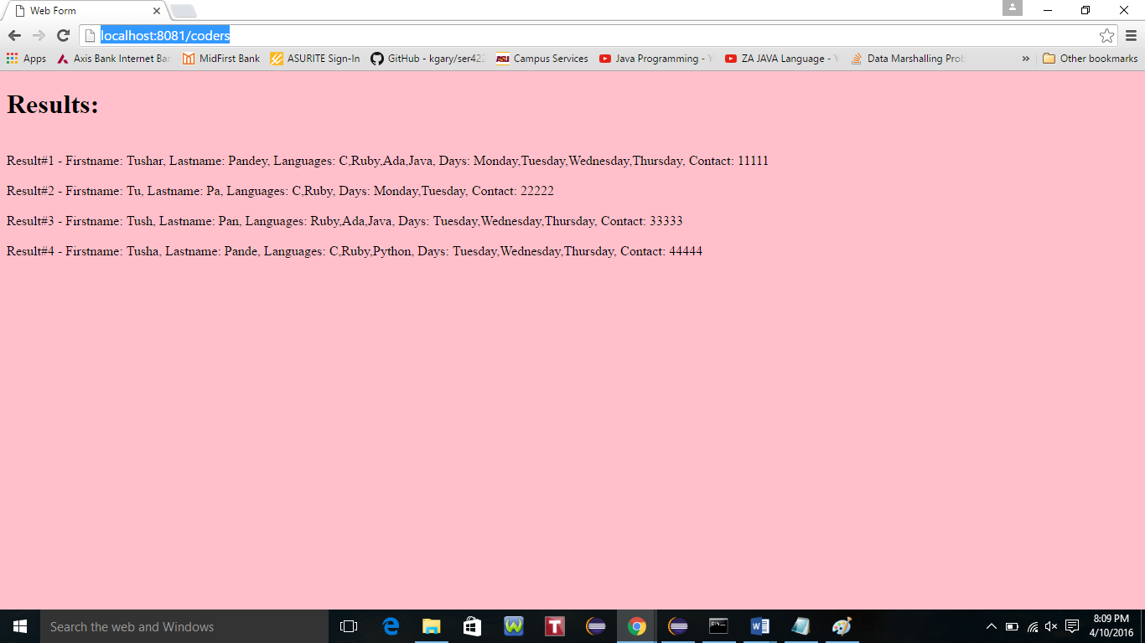

Filtering results from above snapshot when

firstname=T

lastname=Pan

http://localhost:8081/coders?firstname=T&lastname=Pan

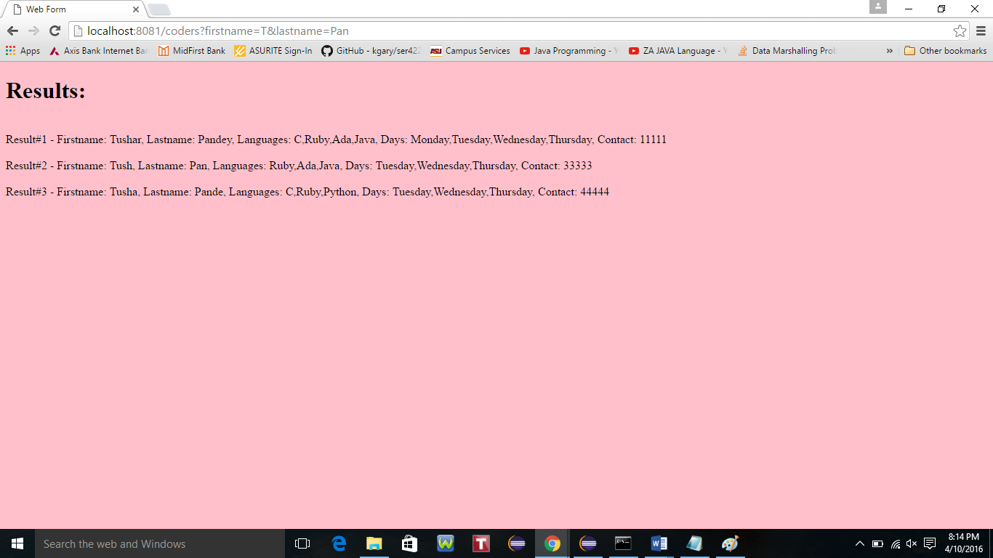

Similarly, filtering results when

firstname=T

lastname=Pan

languages=Ada+Scala

http://localhost:8081/coders?firstname=T&lastname=Pan&languages=Ada+Scala

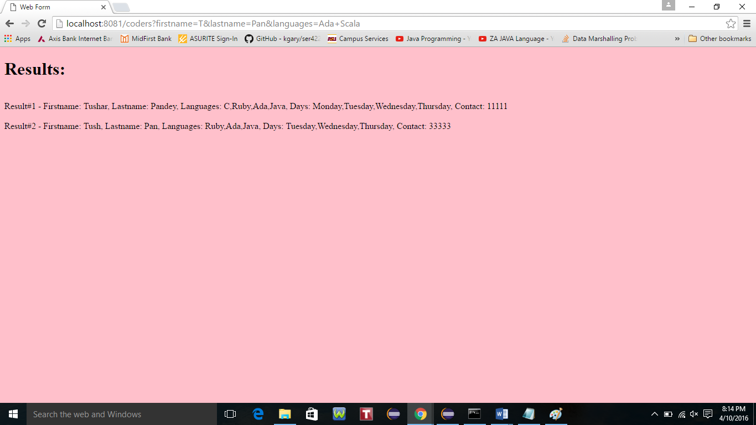

Further, filtering results from above snapshot when

firstname=T

lastname=Pan

languages=Ada+Scala

days=Monday

<http://localhost:8081/coders?firstname=T&lastname=Pan&languages=Ada+Scala&days=Monday>

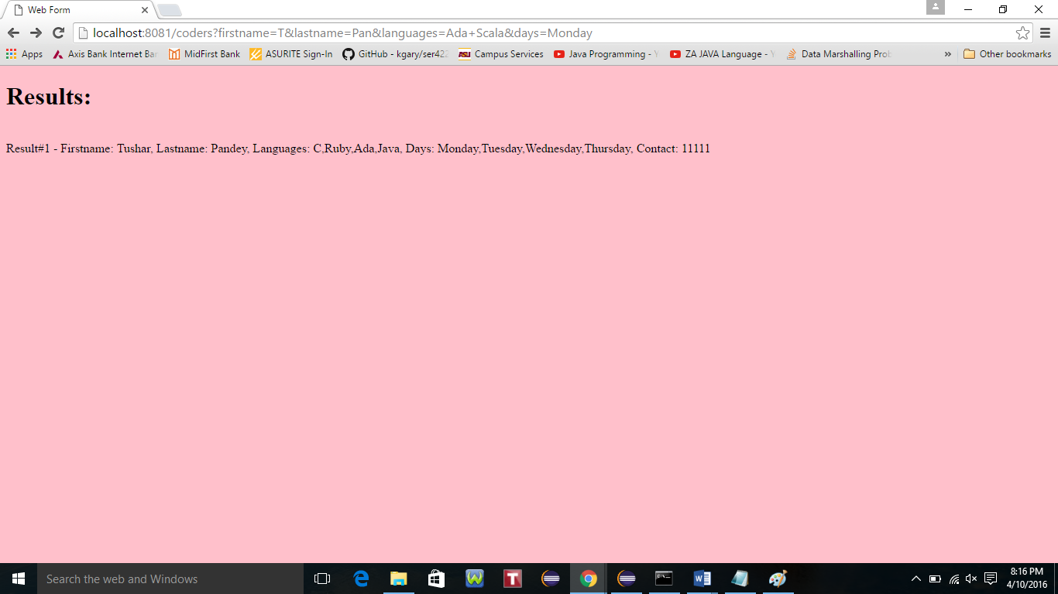

Finally, filtering results from above snapshot when

firstname=T

lastname=Pan

languages=Ada+Scala

contact=33333

http://localhost:8081/coders?firstname=T&lastname=Pan&languages=Ada+Scala&contact=33333

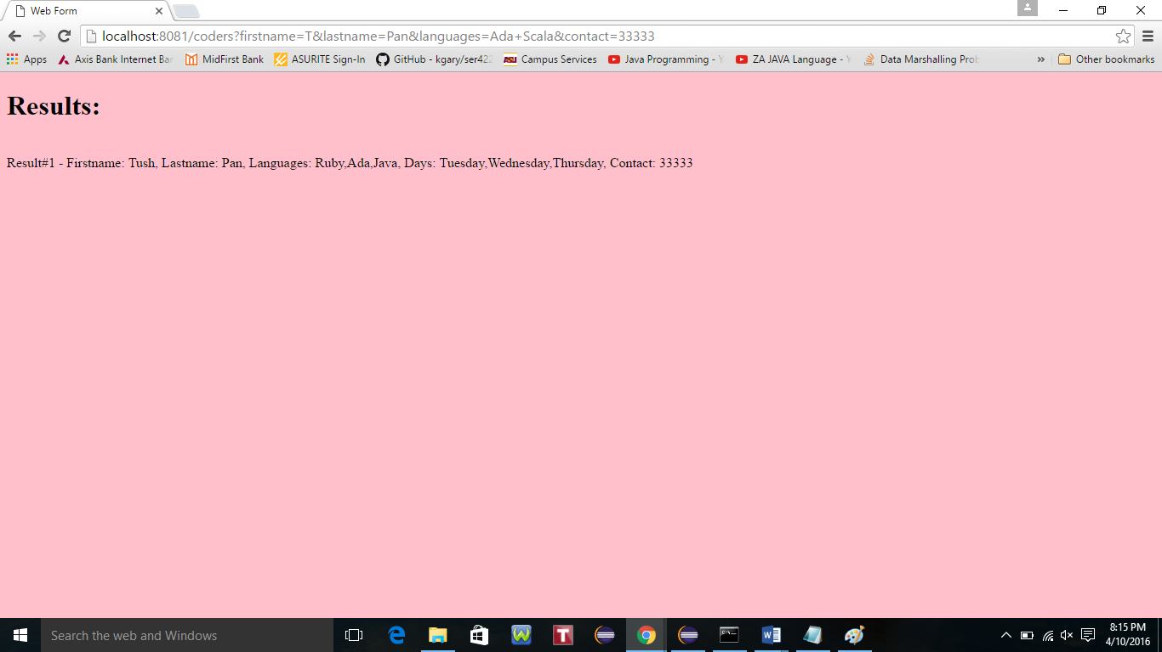

**For Task 2: Redo Task 1 in Express**

Source Code: task2.js, results.jade, webform.jade (in lab4_tpandey1\views) and uses node modules body parser, express and jade present in \lab4_tpandey1\node_modules

1. Created below web form with an additional prompt named ‘Contact Number’. Form mapped to *URL “/” and method GET.*

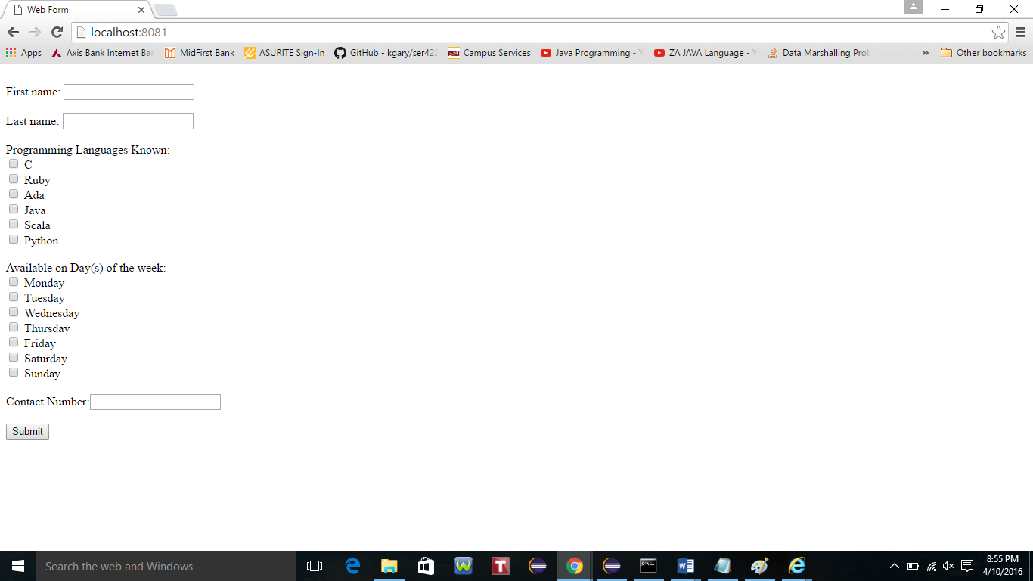

2) Start the server by running task2.js



Enter the required details and click submit.

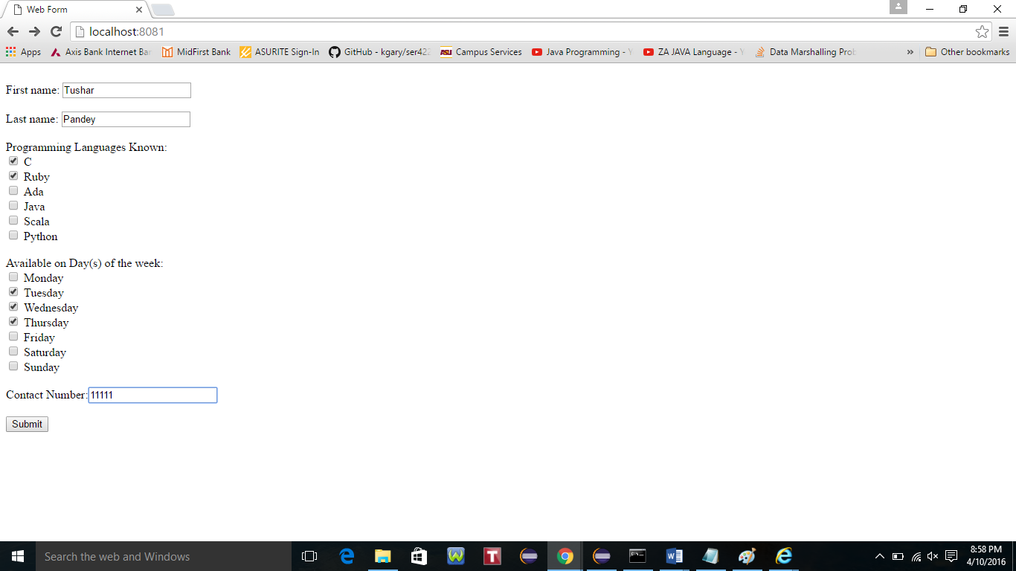

The page displays the message **“The action was successful”** along with the Total number of entries in the array i.e 1 in this case. The server responds with a message stating the action was successful (or not) followed by a count of the number of entries in the array, and then display the same web form as step #1.

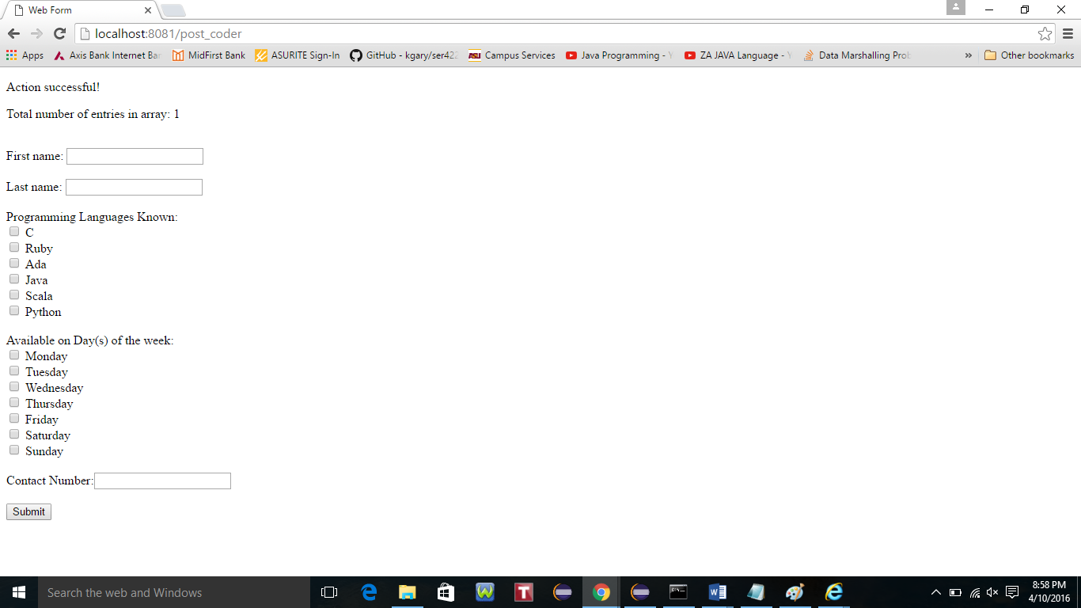

Similarly, enter the other record for testing in further steps. 4 records were added for testing purpose.

If the user provides No value for any of the prompts and clicks Submit to add the empty record, then the program throws an error **“Action failed, please try again”**



3) On the url enter <http://localhost:8081/coders> to display the entire list of element in array. If the browser is a Chrome browser, then set a pink background color.

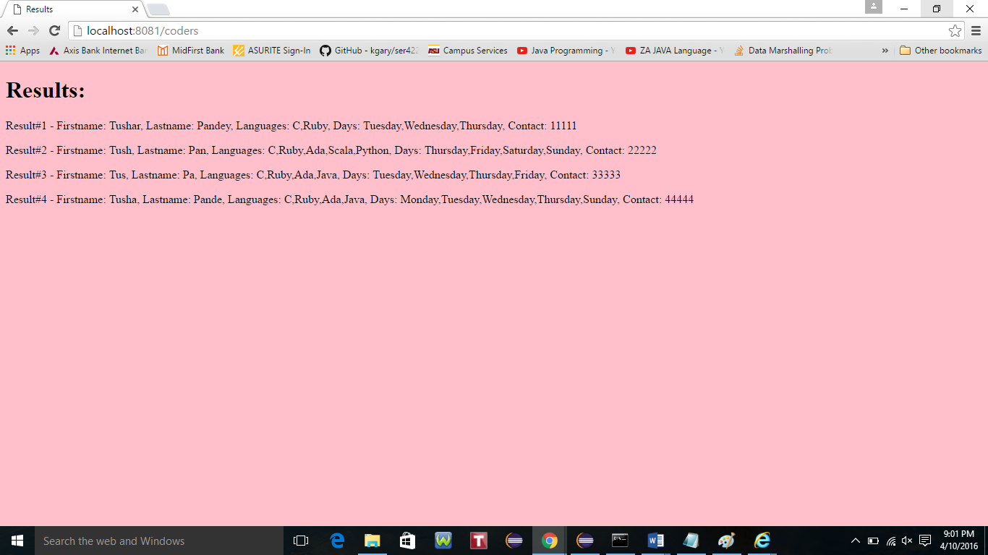

Filtering results from above snapshot when

firstname=T

lastname=Pan

http://localhost:8081/coders?firstname=T&lastname=Pan

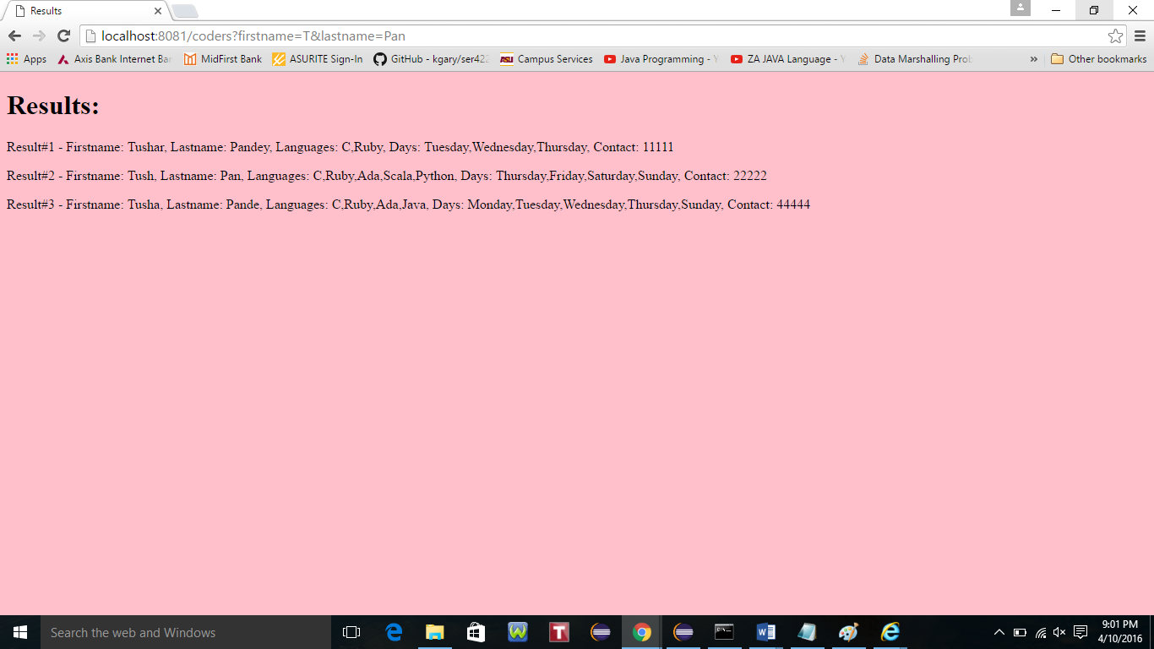

Similarly, filtering results when

firstname=T

lastname=Pan

languages=Ada+Scala

http://localhost:8081/coders?firstname=T&lastname=Pan&languages=Ada+Scala

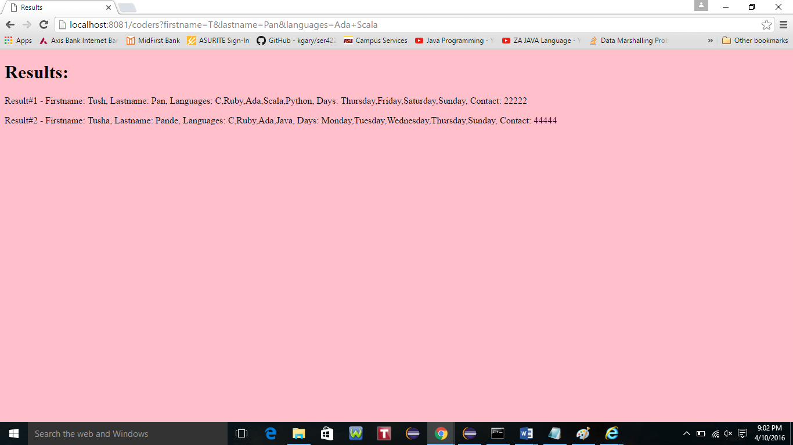

Further, filtering results from above snapshot when

firstname=T

lastname=Pan

languages=Ada+Scala

days=Monday

<http://localhost:8081/coders?firstname=T&lastname=Pan&languages=Ada+Scala&days=Monday>

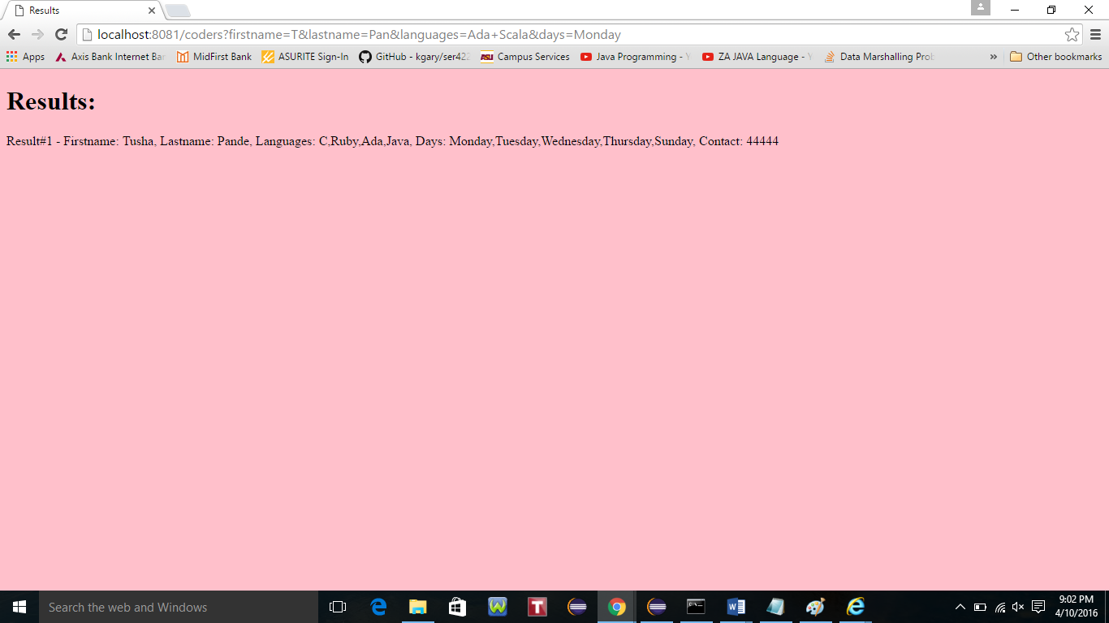

Finally, filtering results from above snapshot when

firstname=T

lastname=Pan

languages=Ada+Scala

contact=22222

<http://localhost:8081/coders?firstname=T&lastname=Pan&languages=Ada+Scala&contact=22222>

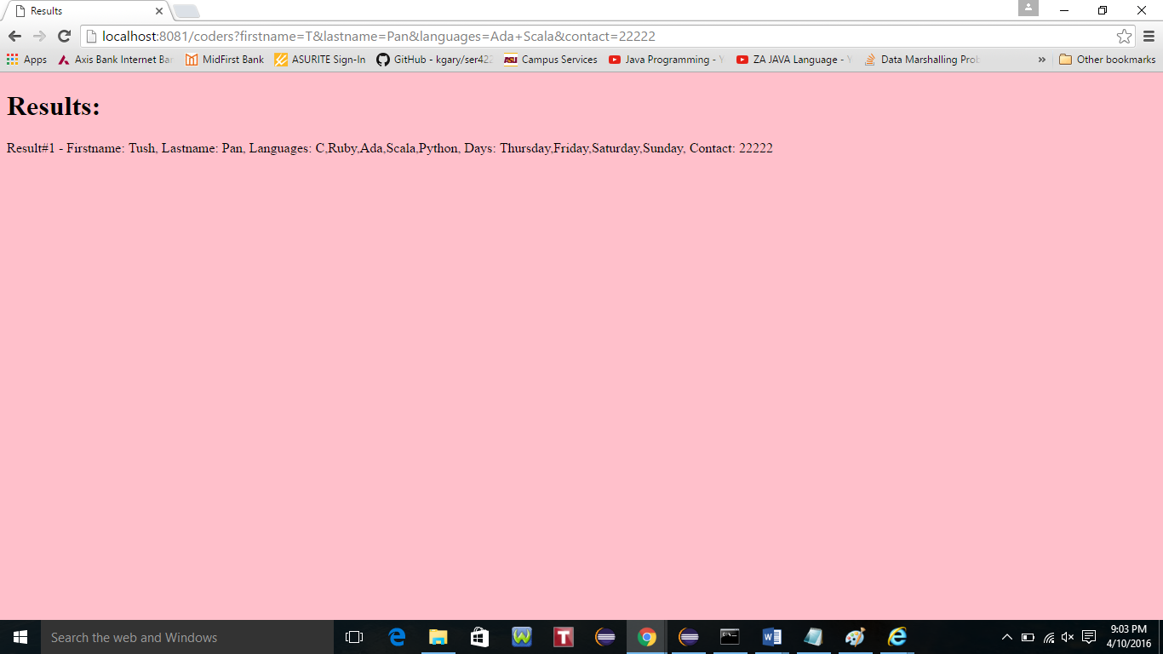

1. Added the ability to filter based on a specific attribute using a RESTful syntax. Specifically, support a GET request on URLs:
   * + - 1. */get_coder/firstname/:name*
         2. */get_coder/lastname/:name*

<http://localhost:8081/get_coder/firstname/Tush>

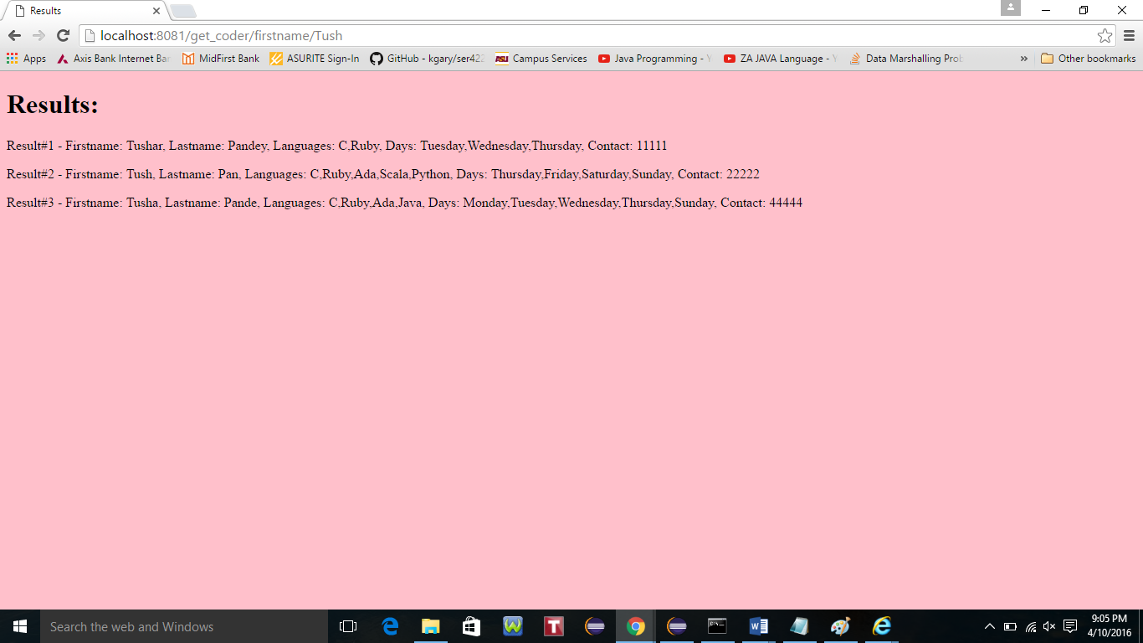

<http://localhost:8081/get_coder/lastname/Pa>

